CURRICULUM VITAE
Nissim Garti, PhD
Profesional Appointments

PROFESSOR EMERITUS 2015
FULL PROFESSOR 2009-2015

Ratner Family Chair of Chemistry 2010-2015
Applied Chemistry, Jerusalem; Israel Department of Chemistry; The Hebrew University of Jerusalem
PROFESSOR 1984–1990
Applied Chemistry; The Hebrew University of Jerusalem
SENIOR LECTURER 1980–1983
Applied Chemistry; Jerusalem, Israel; The Hebrew University of Jerusalem
LECTURER 1977–1980
Applied Chemistry; Jerusalem, Israel; Casali Institute of Applied Chemistry; The Hebrew University of Jerusalem
INSTRUCTOR 1977
Casali Institute of Applied Chemistry; The Hebrew University of Jerusalem

EDUCATION

ACADEMIC APPOINTMENTS AND POSITIONS
Head of the Casali Institute of Applied Chemistry ( second term) 2012- 2016
Member of the Board of Governors and Member of the Management Committee 2011–2014
(Board of Directors) of the Hebrew University (HU)

Chairman of the Innovation Forum of the Israeli Food Association 2013–2016

Member of the Board of Directors and Board of Governors of Hadassah Academic Institute, 2009–present

Member of the HU Committee for Academic Programs Jerusalem, Israel 2013–2014
Member of the Governing Council of the Hebrew University of Jerusalem 2011–2014
Member of the Executive Committee of the Hebrew University of Jerusalem 2010–2014
Incumbent of the Ratner Family Chair of Chemistry 2010- present
Visiting Professor – Sabbatical leave at AgroParisTech, Massy, Paris, France 2010 (June–September)
Visiting Professor – University of Florence, Florence and University of Urbino, Orbino, Italy 2010 (October)
Visiting Professor – ETH, Zurich, Switzerland 2010 (November)
Visiting Professor, Trent University, Peterborough, Canada 2010-2011 (Dec-January)
Senior Officer and Visiting Professor – Sabbatical Leave, Faculty of Engineering, Columbia University, NY, USA 2006
Senior Visiting Scientist – Sabbatical Leave, Department of Engineering, University of Stony Brook, 2006
(SUNY), Stony Brook, Long Island, NY, USA
Scientific Consultant and Visiting Professor – Sabbatical Leave at Archer Daniel Midland (ADM), 2004
Research Center, Decatur, IL, USA
Visiting Professor and Sabbatical Leave at the Department of Chemical Engineering Oct 2003–Feb. 2004
and Biotechnology University of Hiroshima, Hiroshima, Japan
Senior Consultant and Visiting Scientist – Archer Daniels Midland (ADM), Research Center, Decatur, IL, USA 2003–present
Visiting Professor – Department of Chemical Engineering and Applied Chemistry, State University of 2001
New York (SUNY) at Stony Brook, Long Island, NY, USA.
Senior Visiting Scientist, Sabbatical Leave at Nestle Central Research Labs, Nestec, Lausanne, Switzerland 1998–1999
Member – Board of Directors of the Holon Academic Institute of Technology, Holon, Israel 1997–2008
Member – Advisory Board of Directors of the New York Polytechnic University, NY, NY, USA 1998–2000
Head – Graduate School of Applied Science and Technology, The Hebrew University of Jerusalem 1990–1993
Sabbatical leave, Visiting Senior Scientist, Eastman Kodak Research Laboratories, Rochester, NY, USA 1985–1986
Visiting Scientist, The Japanese Society for the Promotion of Scientists, University of Hiroshima, Japan 1984 (summer)
Visiting Scientist, University of Pretoria and the South Africa "Wheat Board", Pretoria, South Africa 1983, 1986 (summers)

Member of editorial boards
MEMBER EDITORIAL BOARD OF FOOD & FUNCTION - THE ROYAL ACADEMY OF CHEMISTRY, CAMBRIDGE, ENGLAND 2011–present
ASSOCIATE EDITOR OF THE JOURNAL FOOD & FUNCTION 2011–2014
ASSOCIATE EDITOR OF THE JOURNAL OF AMERICAN OIL CHEMISTS SOCIETY (JAOCS) 2008–2012
MEMBER OF THE EDITORIAL BOARD OF JOURNAL OF DISPERSION SCIENCE & TECHNOLOGY 2002-2006
MEMBER OF THE EDITORIAL BOARD OF COLLOIDS AND INTERFACES (B) 2008-2010
REGIONAL EDITOR AND EDITOR OF THE APPLICATION SECTION OF CURRENT OPINIONS. 2004–2009t
MEMBER OF THE ADVISORY BOARD OF THE JOURNAL OF CHEMISTRY AND MATERIALS SCIENCE 1998–2004
MEMBER OF THE ADVISORY COMMITTEE OF JOURNAL OF COLLOID AND AND MATERIALS SCIENCE 1996–2000
MEMBER OF THE ADVISORY BOARD OF THE JOURNAL OF DISPERSION SCIENCE AND TECHNOLOGY 1986–2000
MEMBER OF THE ADVISORY BOARD OF THE BRAZILIAN JOURNAL OF CHEMISTRY 1994–1998
MEMBER OF THE ADVISORY BOARD OF FOOD MICROSTRUCTURE 1992–1996

Industrial Achievements
2013- Establishment of the start-up of Lyotropic Delivery Systems (LDS)- Novel Lyotropic Liquid Crystals (LLC) and nanodomains technology for drug delivery.

2016 - New set of products under the name of Hygia produced by Ananda Scientific (Colorado, USA) - Softgels , instant powders, and liquid formulation of CBD for fast adsorption and enhanced bioavalability .

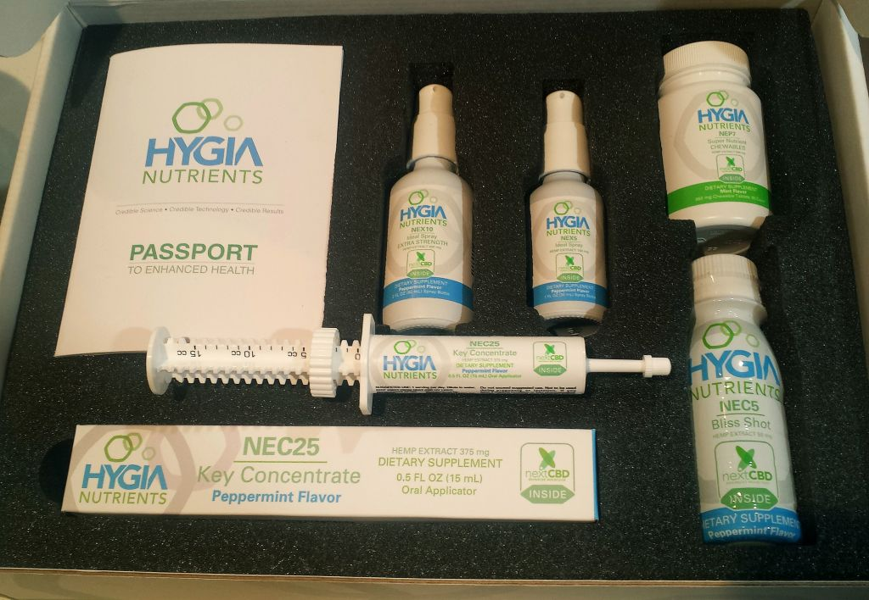

2012- 2015 – Novel rich in DHA Omega-3 Fatty Acids for Enhanced Delivery by Enzymatic interfacial trans esterfication. The new product is the only supplement in Israel that contains real, pure and concentrated DHA. Product sold using the name of AXOM3.
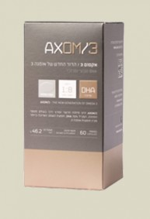

2003-2008 NutraLease, Founder of a new start-up - NutraLease - 'New Vehicles for Improved Bioavailability of Nutraceuticals' (with Yissum and ATI).

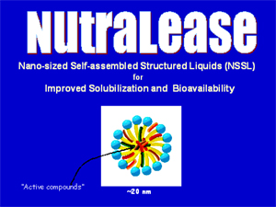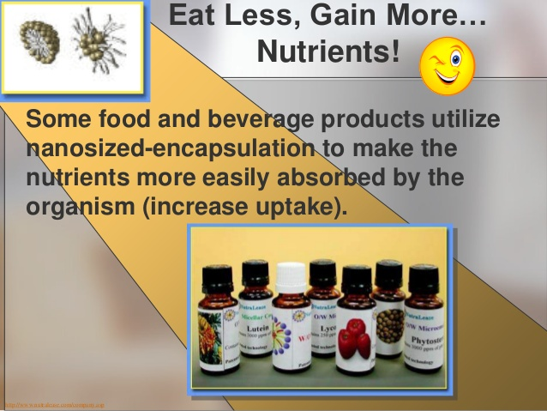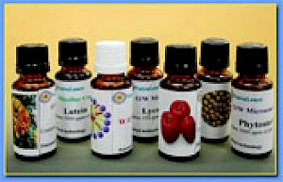
2000-2001 - Ganaspati-India, Bought the technology for the production of Lysolecithin by enzymatic process in microemulsion as microreactor.
1998-2000- FenuPure-Adumim and Origin, New Hydrocolloid for Lowering Glucose Levels for Diabetics'. New nutraceutical and food supplement extracted from fenugreek seeds. Sales started June 2000 by Adumim Chemicals and Origin.
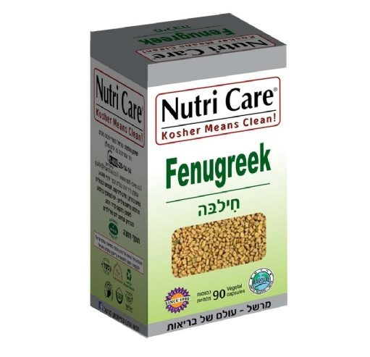
1995- Green Clouds, Founder of a new start-up company "Green Clouds" Ltd., for the development and manufacture of Electric Foggers, based on ultrasound technology for rupture of droplets.
1995- Lycored, Co-developer of new method of extraction and formulation of lycopene from tomatoes.

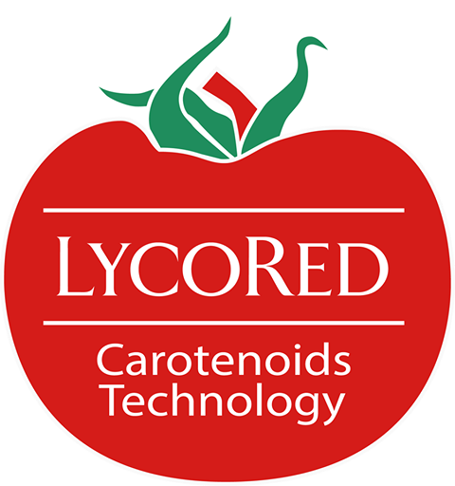
1994- 1997 - FDG-Odyssey, Establisher of a new company, FDG (Fenugreek gum), together with Yissum and Odyssey Ltd., Boston, for R&D and production of Fenugreek gum to remove cholesterol from liquid foods and reduce sugar levels in humans.
1994-1995, Developer (with S. Ezrahi and A. Aserin) of "new fire resistant hydraulic fluids based on microemulsions", (evaluated with great success by IDF).
1993, Developed new-epoxy-silicone, water-borne, non-stick, lubricious coatings and signed an agreement with Decora Manufacturing for the production of these coatings.
1993, Developer (with A. Aserin) of "new cleaning system based on detergents solubilized within microemulsions" to replace trichloroethane (Pazclean 12). Process developed for Paz Oil Co.
1993, Developer of a new method for "removal of cholesterol from butter and milk-cream by natural occurring absorbents".
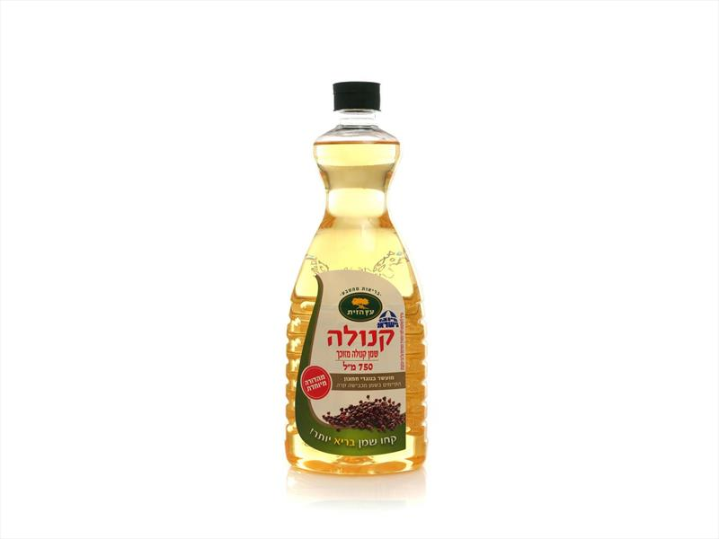
1993- Dipol, Founder of a new company, " Dipol.", for the development and manufacture of TDS (Time Domain Dielectric Spectrometer) for structure characterization if dispersed particles and droplets, and moisture matters.
1991, Signed three agreements with Eastman Chemicals, Kingsport, Tennessee, USA. for: (1) production of SSL of the products, (2) baking premixes in the USA and, (3) mutual marketing (Adumim and Eastman) in Europe.
1991, Developer of new "self-cleaning lubricating rifle oil" for the Israel Defense Forces. In production by Paz Oil Co. Ltd. (1991).
1991, Developer of new "water soluble cutting and lubricious oil" for the use by the Israel Defense Forces (manufactured by Paz Oil Co., Ltd.).
1990, Developer of new "water soluble mineral oils" and "forging oils" for Paz Oil Co. Ltd., Israel. Commercial formulations launched on the market (1992).
1988-1990, Developer of several new emulsion formulations: Water in oil emulsion - pan release - Adolease Oil in water - orange oil cloudy - Adocloud Wax-resin emulsion - Adocol (All manufactured by Adumim Chemicals).
1988, Developer of "Adolak" new technology for the encapsulation of unsaturated fatty acids by calcium salts. A new product designed to bypass Rumenous of lactating cows and to supply additional energy in order to increase milk production of cows after calving. Process
transferred to Koffolk - Animal Feed, Beer Sheva.
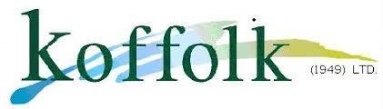

1987, Developed unique "new technique to determine levels of cholesterol in blood", process developed for IDL Ltd., Jerusalem (1988).
1985-present, The SSL technology was transferred to 14 companies whose construction of manufacturing plants for implementation of this technology was done under my direction, supervision and advise:

1979- Adumin Food Ingredients, and Adumim Foods- Mishor Adumin , Israel
1985 - Mexico - Guadalajara, Arancia-Polibasicos
1986 - South Africa - Johannesburg, Epic Oil;
1987- Peru - Lima, Alpamayo.

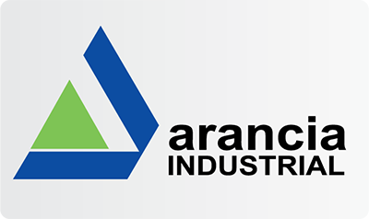
1988 - U.S.A. – Atlanta, USA , International Specialty Foods, Ltd.
1988 - Brazil - Rio de Janeiro, Anpal ltd
1988 - Argentina – Rio Tersero, Cordoba, Alpha ltd
1988 - Ecuador - Quayaquil, Oleica ,Ltd
1989 - USA. - North Carolina, ISP, ltd
1990 - Colombia - Cali, Maizena
1992 - Serbia - Zrenjanin, D'jamant ,Ltd
1993 - Chile- Santiago, Molypac, Ltd
1995 - India, New Delhi, Bajaj – Anaccord, Ltd

1979-2010, Chief Scientist and establisher of Adumim Chemicals Ltd., a plant constructed on the basis of a unique original process developed by N. Garti and E. Pinthus (student) to produce sodium stearoyl lactylate (SSL), an advanced surfactant, bread improver and food conditioner. The plant produces at present over 10 additional products most of them based on innovative technologies developed at the Casali labs (annual sales of $6-8,000,000).

CONSULTING POSITIONS

Neoprol- Integra- Novel Intravenous delivery vehicles 2018- present

Straus Salads - Karmiel. Israel 2019

VICUT – Novel Device to Detect and Remove Flat Column Cancer Cells 2017-2018

Ingredion (National Starch) (New Jersey, USA) 2012-2013
General Mills, USA – Israel Branch in Jerusalem. 2012–2014
Safta Gamilla Cosmetics, Tefen, Israel 2012–present
Zoar Dalia , Israel 2013- present
PureN Neutraceuticals, Tel Aviv, Israel 2011–2013
Scientific Consultant to KRAFT (presently Mondelez), Saclay, France, Reading UK 2011–2013
Felco-Ice creams, Rechovot, Israel 2013
BARAKE Foods, Alon Tavor, Israel 2010– present
Scientific Consultant to Marine Cosmetics and Buthai Cosmetics, Israel 2010–2011
BioPhore Intrernational, Ltd. – USA-Israel-Japan 2008
Scientific Consultant to PepsiCo Inc. (Texas) 2008–2010
Soglowek Foods, Israel 2007–2010
Scientific Advisor to the Regional Israeli Court House on Firms Disputes 2009–present
Scientific Advisor to Archer-Daniels-Midland (ADM – the Supermarket of the World), Decatur, IL, USA 2009–2013
Consultant to Milouban, Producers of Cotton Linters and Fibers, Haifa, Israel 2002–2005
Founder, CEO and Member of the Board of Directors of NutraLease 2001–2009
Chief Scientist and Member of the Board of Mempile, Israel- Japan 3D Storage of Data 2001–2004
Chief Consultant to Shemen Edible Oil Industries, the largest vegetable oil producer in Israel, Haifa, Israel 2000–2010
Consultant to Medisim-Health Devices, Jerusalem, Israel 2000–2002
Consultant to Tet-Beit and Vita Ltd., Fats, Oils, and Margarine Producers 2000–2001
Consultant, “LycoRed Natural Products” Israel (producers of Lycopene and natural products) 1999–2011
Advisor to Enzymotec Biocatalysts, Migdal Ha'Emek, Israel 1999–2000
Scientific Advisor to Nestle (Nestec) Research Center, Lausanne, Switzerland 1998–2004
Advisory Board Member of the Polytechnic University, Brooklyn, New York, USA 1998–2001
Senior Advisor to The Galilee Society for Health Research and Services, Elabon, Israel 1997–1999
Scientific Advisor to the General Managing Director of the Ministry of Industry and Commerce, Israel 1997–1999
Chief Scientist and member of the board, Dipole Corp. 1995–1998
Consultant, Quest International, Naarden, Holland 1995–1998
Consultant, Unilever Corp., Vlaardingen, Holland 1996
Chief Scientist and member of the board, Green Clouds Ltd. 1996
Consultant on crystallization and polymorphis of drugs, Teva Pharmaceuticals, Israel 1993–2003
Consultant, Scientific Steering Committee – Decora Manufacturing, Fort Edward, NY, USA. 1991–1996
Consultant, South Bakels Ltd., Johannesburg, South Africa 1986
Consultant and Visiting Senior Scientist – Research Labs, Eastman Kodak, Rochester, NY 1985–1998
Consultant, member of the Steering Scientific Committee of International Diagnostic Labs (IDL) 1985–1987
Visiting Scientist, University of Pretoria and the South African Wheat Board, Pretoria, South Africa 1983–1986
Consultant, Premier Milling and Epic Oil Ltd., Johannesburg, South Africa 1981–1982

